**Sophos Firewall**

**Reset a Forgotten Admin Password**

How to rest the admin password of the Sophos firewall?

**Pre requisites:**

Make sure that the Sophos firewall device is already running on V17.5 or V18 or above.

Also Ensure to use the Micro USB slot or the RJ45 COM port slot for the console cable connectivity to computer.

Open the device manger and then check the ports section to identify the COM port number detected for this console cable connection.

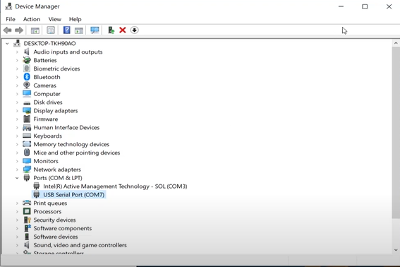

We are using the puTTy tool to access the console of the device.

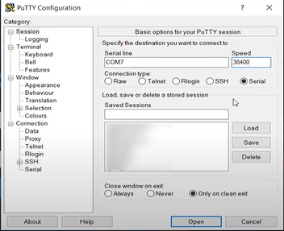

Click on open. Now the console screen is open at the password prompt by default.

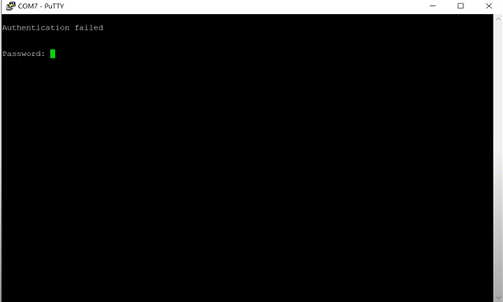

Now you need to type in the password as **RESET** in uppercase and then hit the enter key.

It will show four options. We need to type in option no. 4 to reset the password of the user admin and hit the enter key.

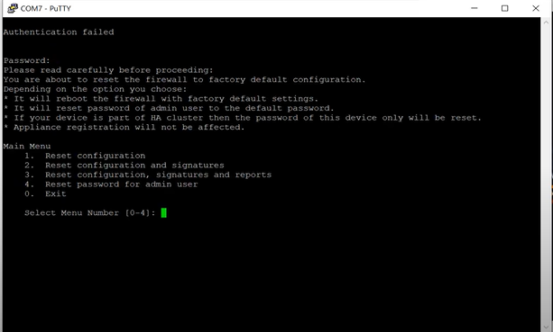

Type in “Y” to confirm this action and then hit the enter key again to reset the admin password successfully.

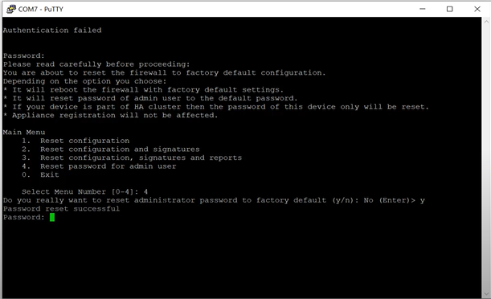

After this activity is done. We can login to the Sophos firewall with a default password of “**admin**” and then it will immediately ask you to change the admin password to something that is more secure.

Once this is done we can successfully see the dashboard page and continue using the Sophos firewall web user interface.

*** THE END ***